**DNSSEC Report**

**Task 1 -  DNS amplification attack simulation and mitigation**

**Step 0:-**

1. First we setup and run the docker file given to us in the Task.

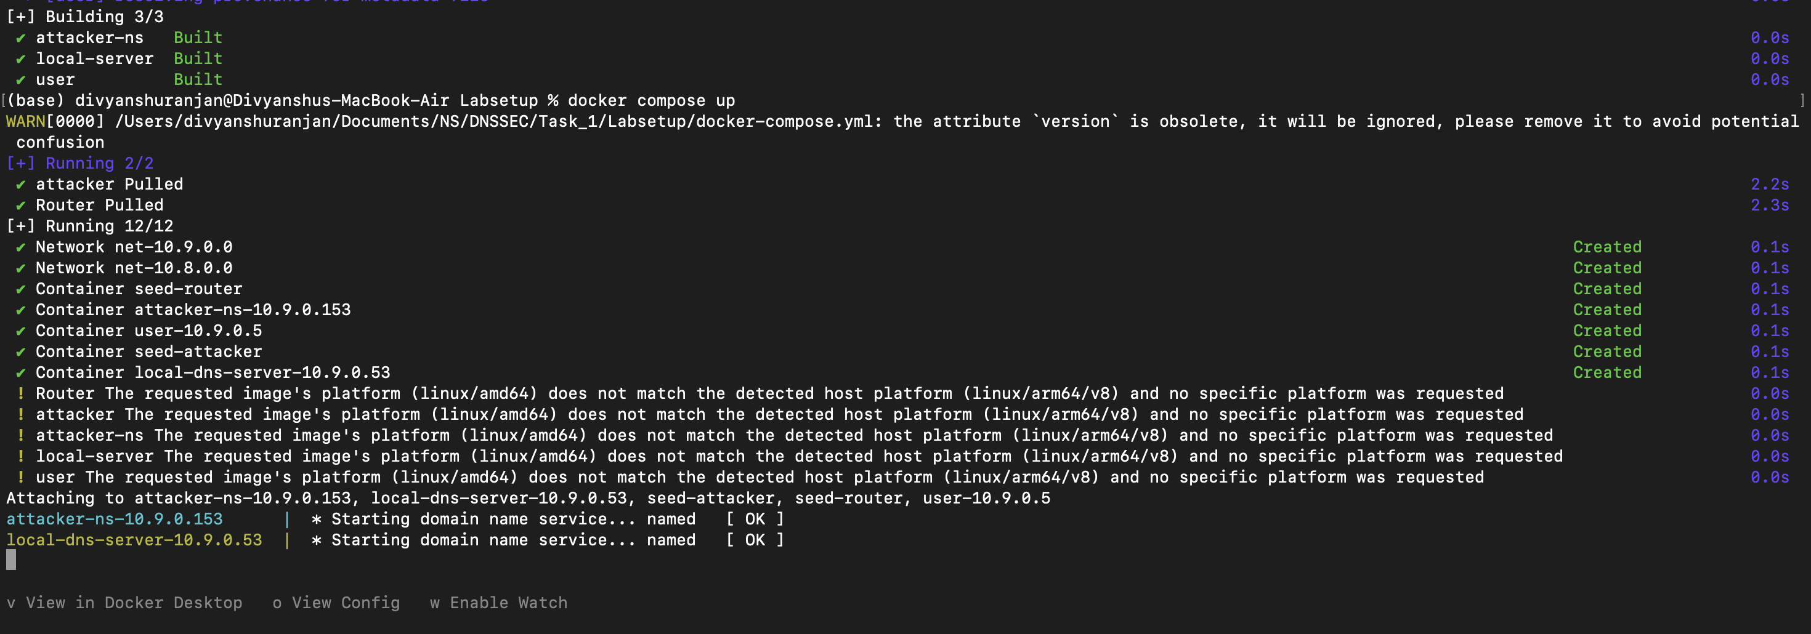

**Step 1:-**

1. We setup attacker terminal using the command docker exec -t attacker-ns-10.9.0.153 bash
2. Now we run the given command **dig @10.9.0.53 google.com** from attacker terminal.

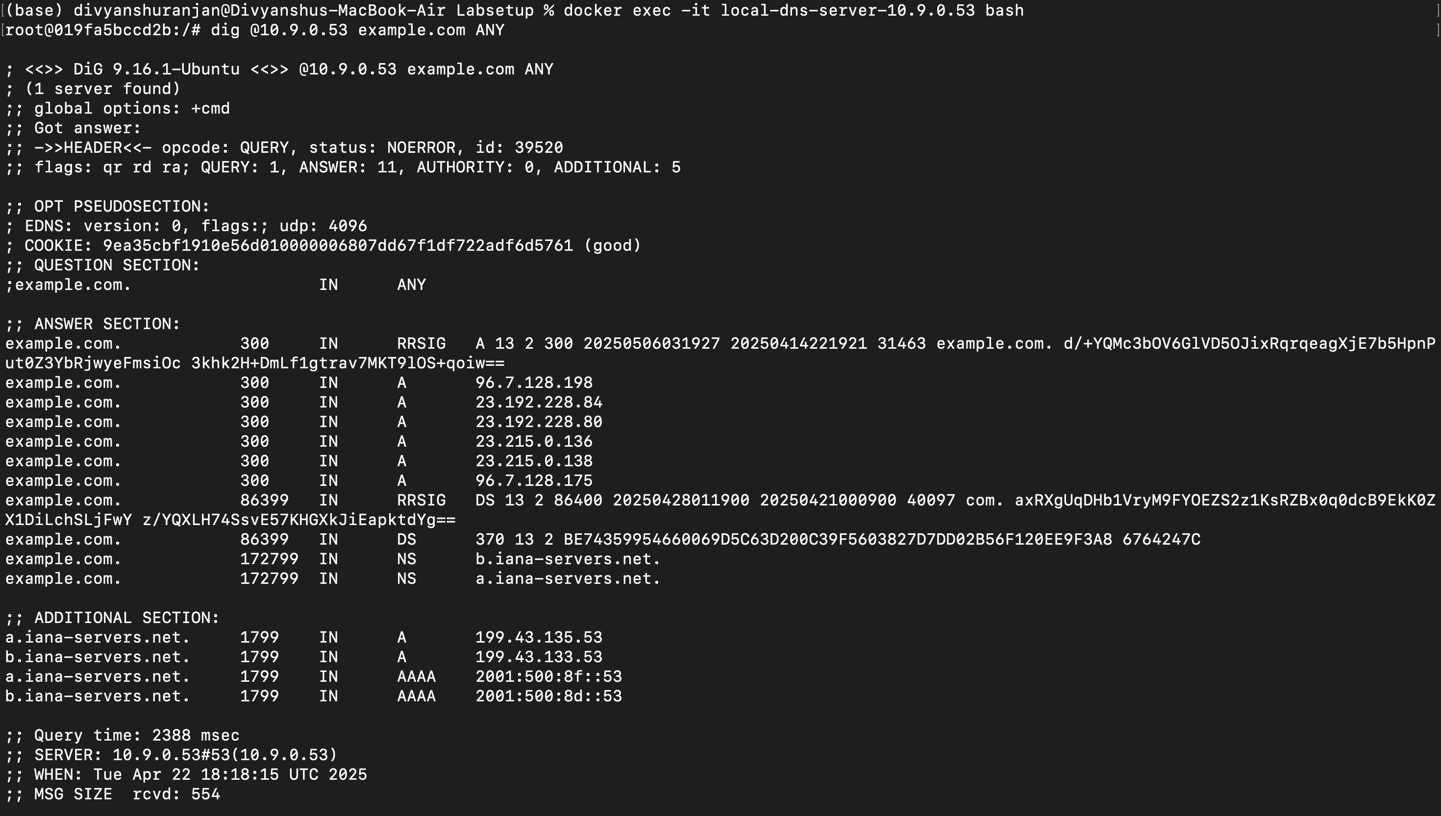

**Step 2:-**

1. **Send Spoofed DNS Query**

* Now we write the script to send spoofed DNS query where source IP is set to user’s IP address.

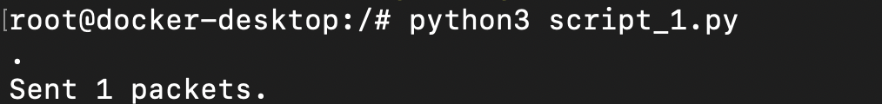

1. **Capture DNS Request and Responses**

* Now here we use Tcpdump on attacker and user’s machine to capture incoming or outgoing packet.



**Tcp dump on attacker machine**



**Tcp dump on user machine**

* Now we need to calculate the amplification factor, which is :-

$$Amplification factor= \frac{Size of DNS Response (bytes)}{Size of DNS Request (bytes)}$$

Therefore, amplification factor in our case = $\frac{498}{51}=9.7647$

1. **Send a Burst of Packets**

* Here we send DNS queries for 5 seconds continuously.

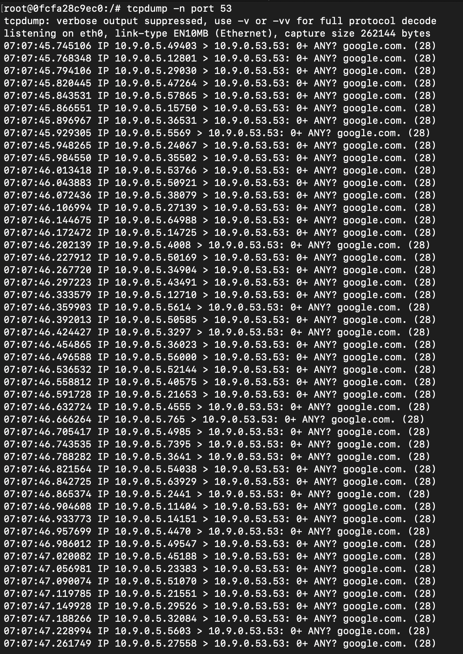

**Attacker tcpdump**

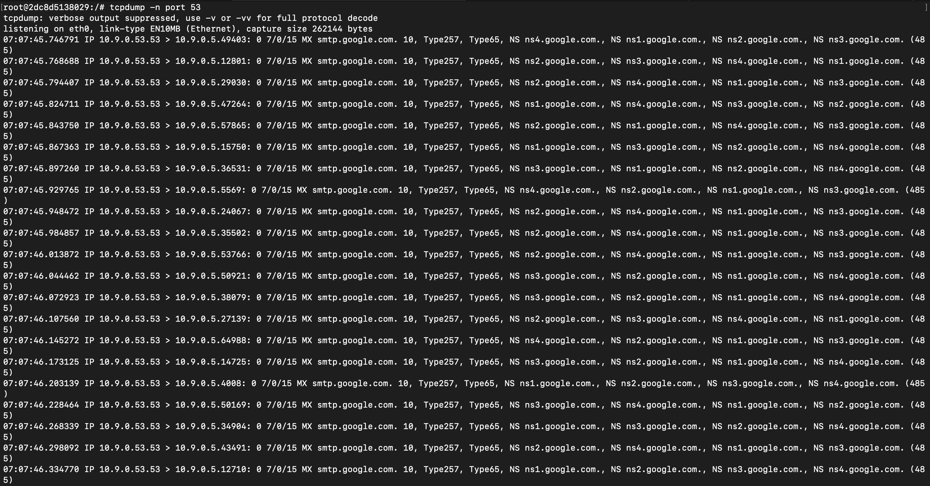

**User tcpdump**

**Step 3:-**

1. **Mitigating the attack**

* In this step, we change the dns conf file to limit the rate of DNS query to 5 responses in 5 seconds. This is done to prevent DOS attack on a server.
* Here in the below ss

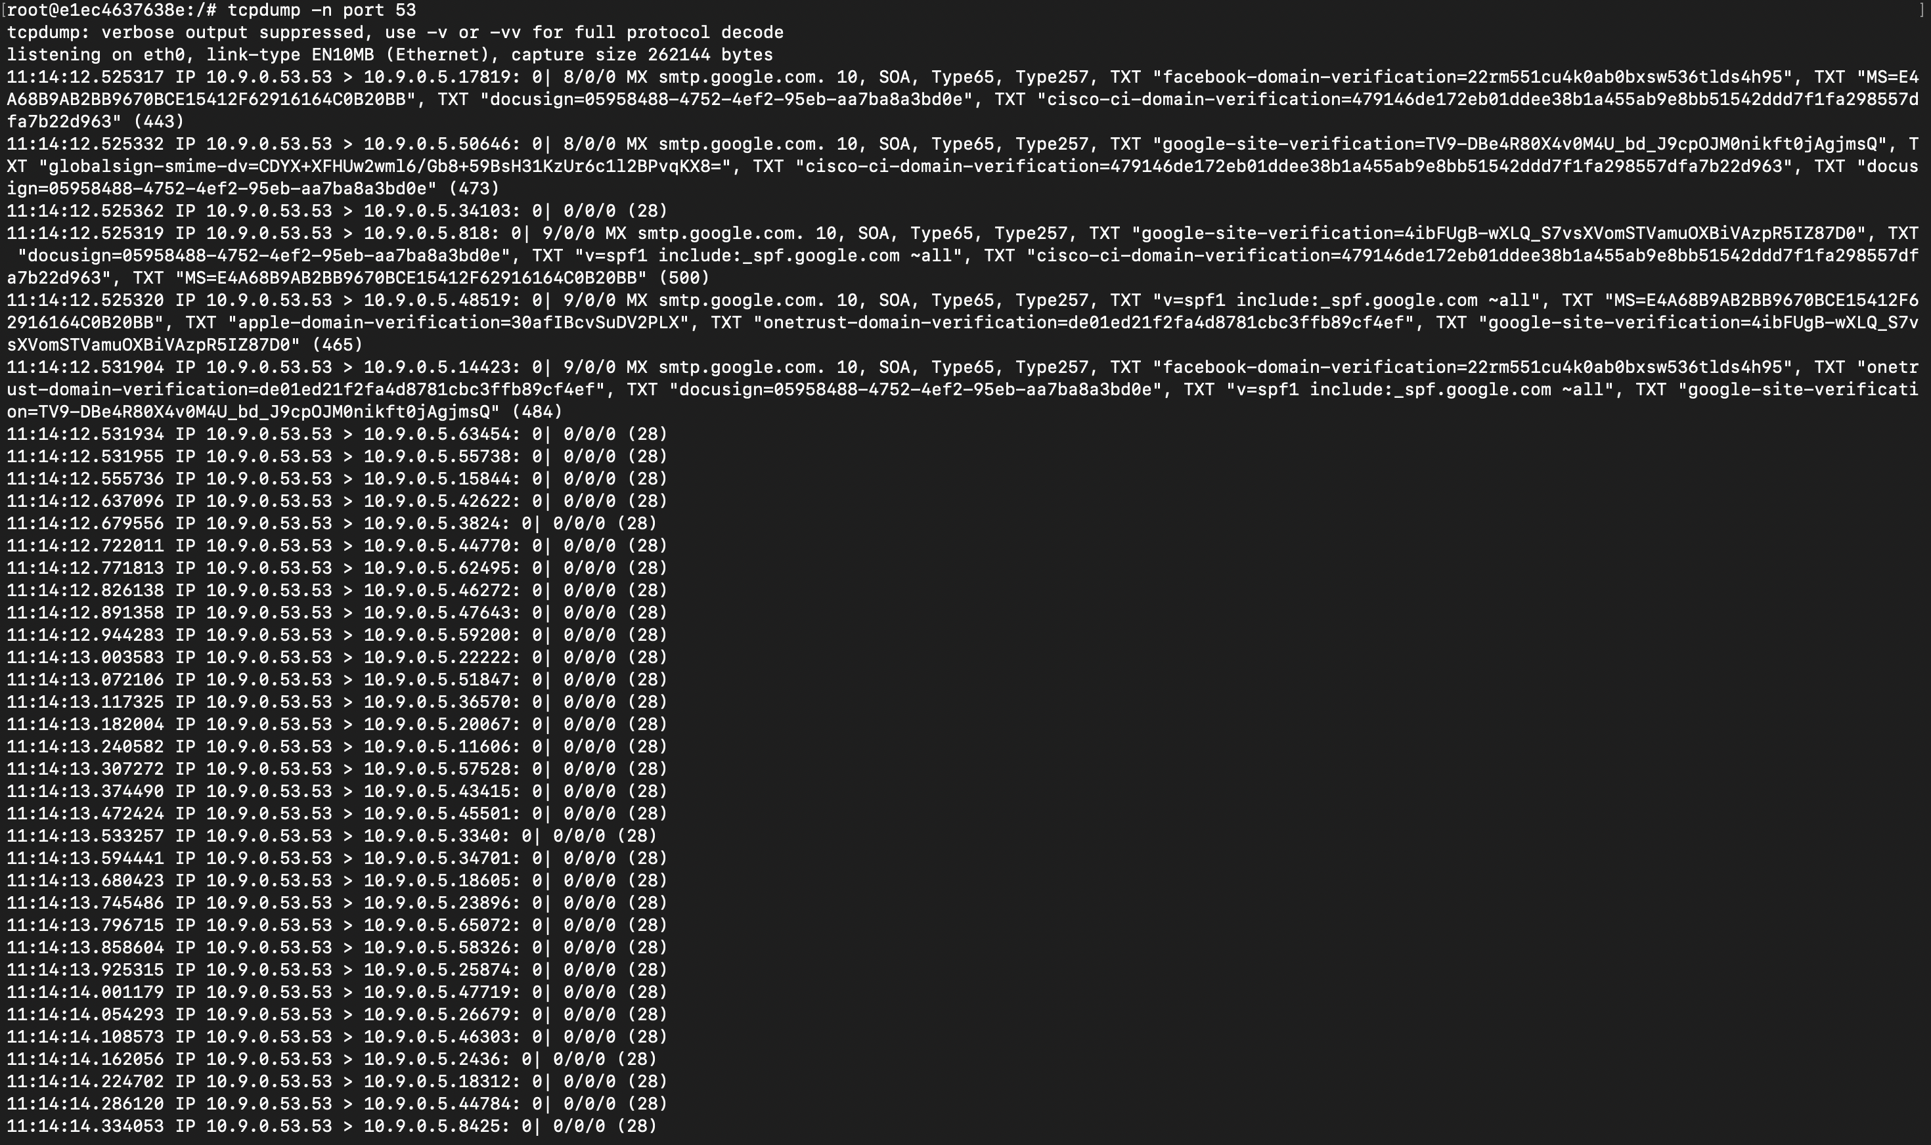

User tcpdump

**Task 2 -  DNS amplification attack simulation and mitigation**

* Here we build the docker first as given in assignment word

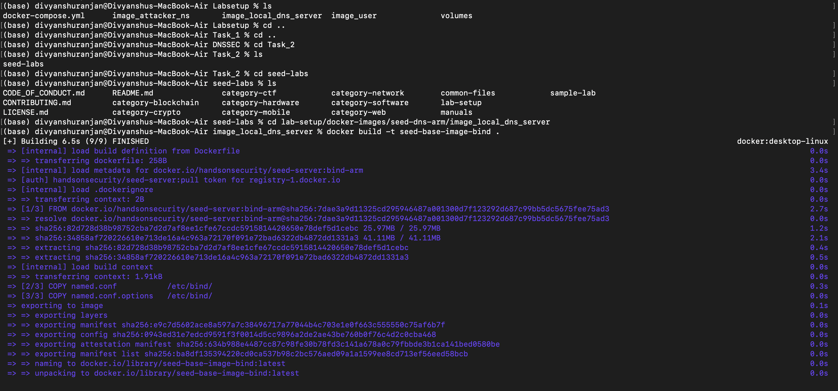

* Now we make KSK and ZSK keys for example.edu server, and then sign the edu.example.db using it

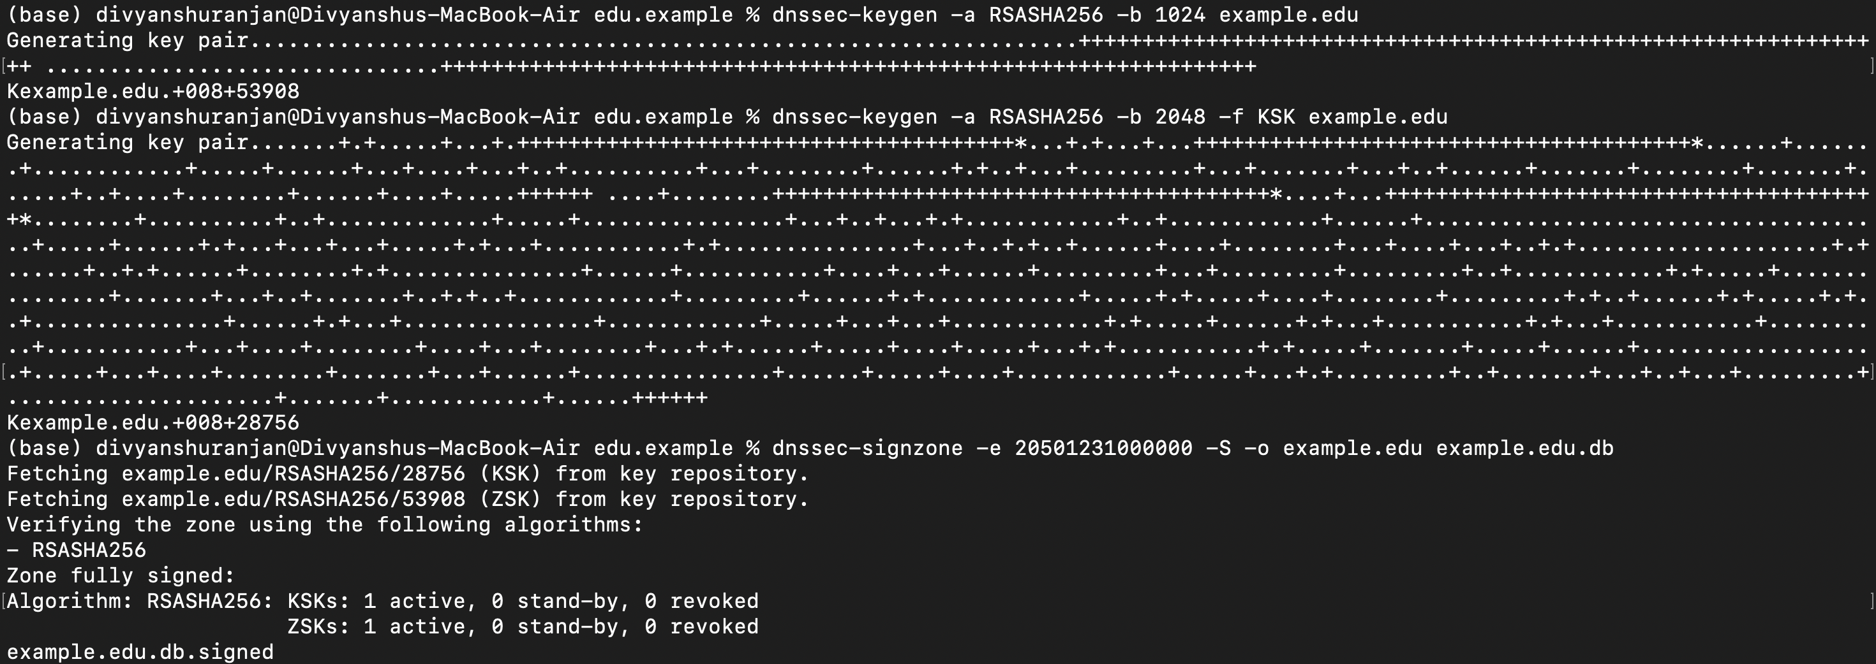

* Now we do same for edu.db (making KSK and ZSK keys) and sign it

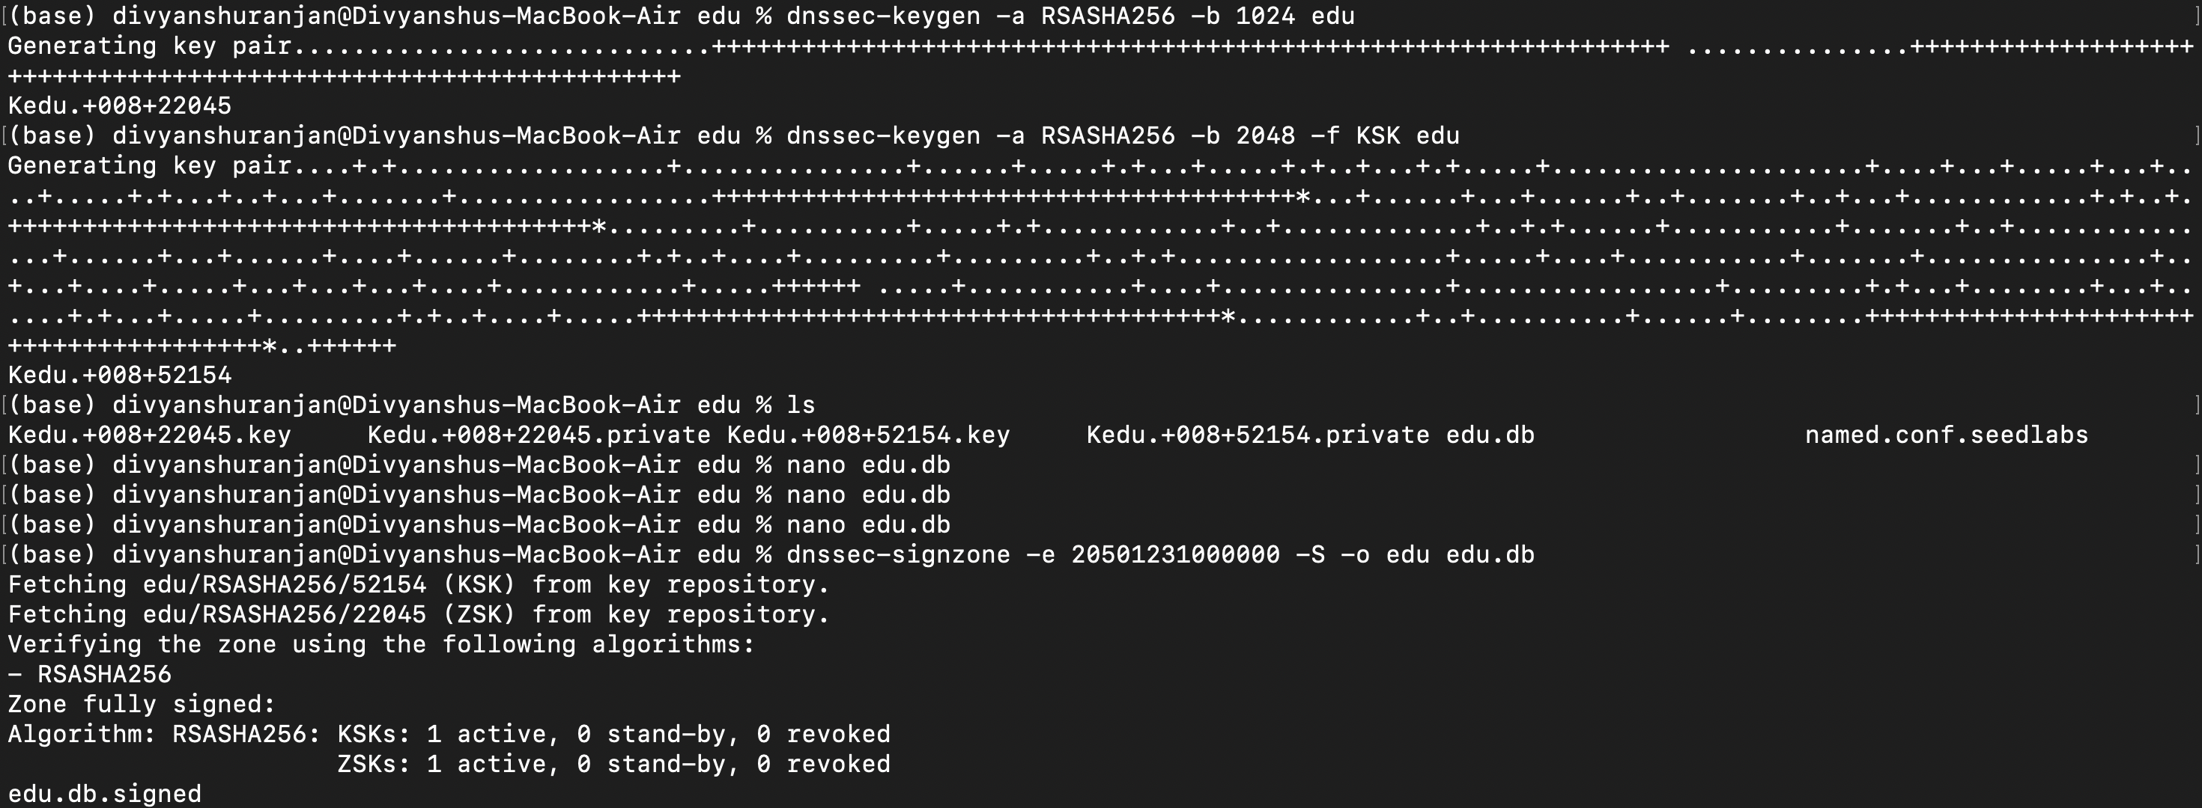

* Done same for root.db file (ZSK, and KSK Key), and sign it

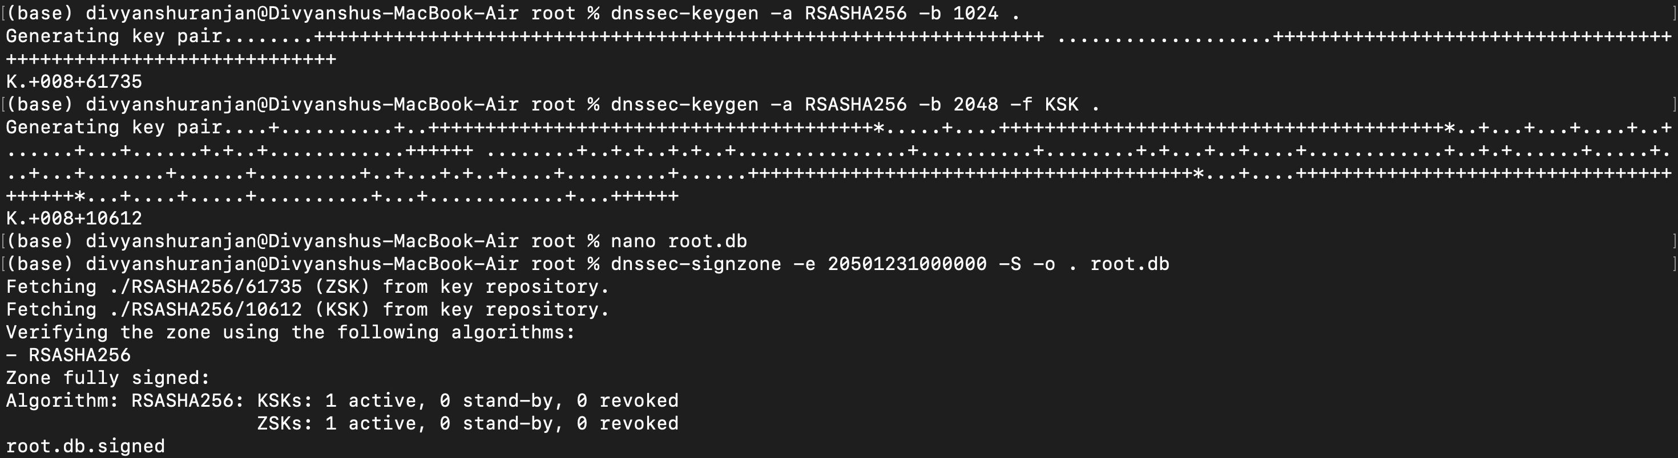

* Here we can see that NOERROR and Flags – ad came, that means everything is configured perfectly.

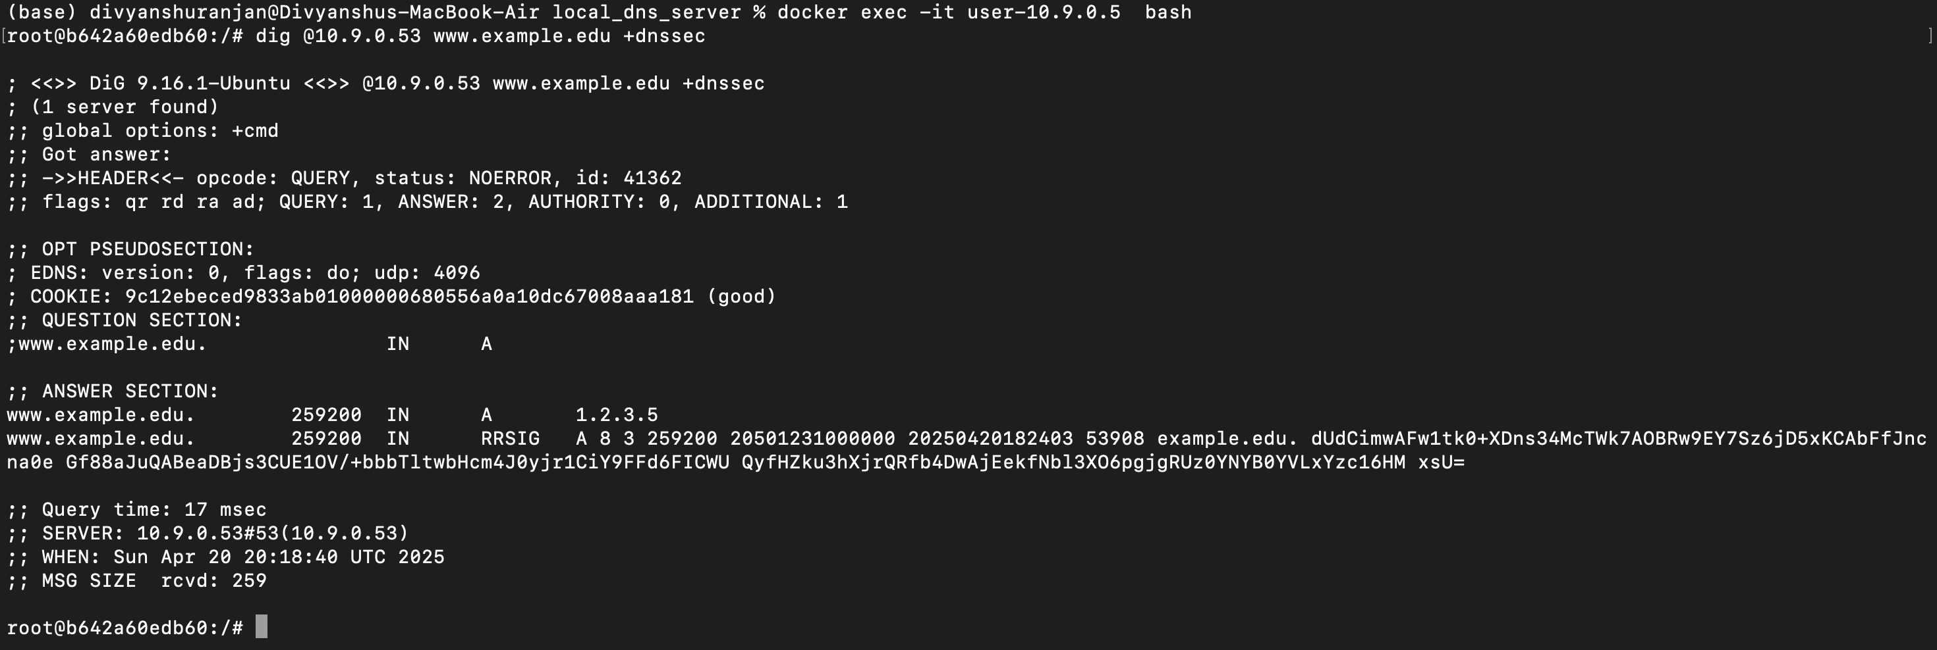

**Task 3: DNSSEC Signature Replay Attack**

## **Step 1: Perform the Signature Replay Attack**

### 1.1 **Capture DNSSEC Traffic**

* **Tool**: Use tcpdump or Wireshark.
* **Command** (tcpdump example):

### 1.2 **Analyze the Capture**

* **Open** the .pcap file in **Wireshark**.
* **Filter**: Use the display filter dns or dns.qry.name == "example.edu" (replace with your test domain).
* **Find** a packet that contains:
  + RRSIG (DNSSEC Signature)
  + A, NS, SOA, etc. records
* **Save** this response for replaying.

### 1.3 **Replay the Captured Signature**

* Extract the response from the .pcap or manually craft a DNS response using scapy, dig +dnssec, or a replay tool.
* Send the **old signed response** to the DNS resolver using scapy or a packet injection tool like tcpreplay.

## **Step 2: Observe the Attack**

### 2.1 **Monitor the Resolver’s Behavior**

* **Check if the resolver accepts the replayed response**.
* Monitor with:
  + **Wireshark** on the resolver to see if the response is accepted.
  + **Logs** on the resolver (/var/log/syslog or BIND logs).
* **Success Criteria**: If the old signature is accepted without checking freshness (expiry), the attack is successful.

### 2.2 **Explain the Risks**

* A successful replay means:
  + **Stale or malicious DNS data** could be inserted.
  + **DNS cache poisoning** becomes possible even with DNSSEC.
* This defeats the purpose of DNSSEC’s integrity if expiration checks are skipped.

**Importance of Expiry:**

* RRSIGs have Valid Until **(Expire)** and Inception timestamps.
* Proper checking prevents **indefinite reuse** of valid-looking signatures.

## **Step 3: Mitigation – Prevent Signature Replay**

### 3.1 **Implement Time-Based Validity in Zone Signing**

* Use short TTLs and set expiry with dnssec-signzone:

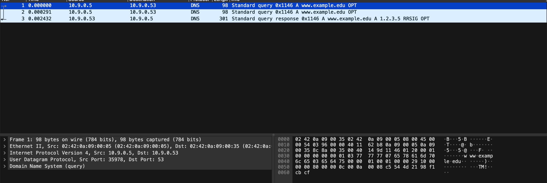

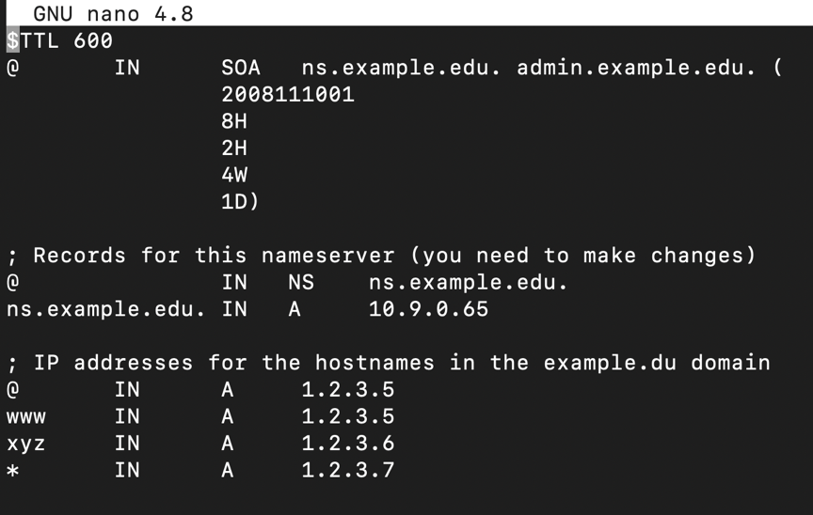

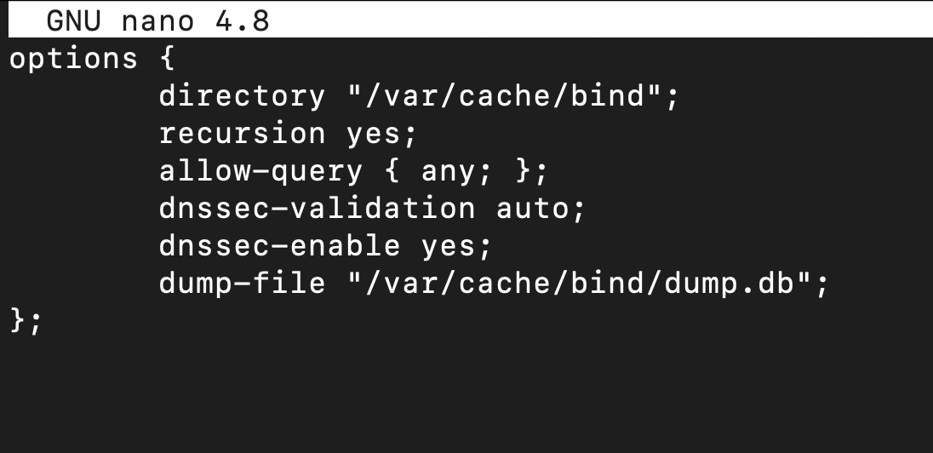

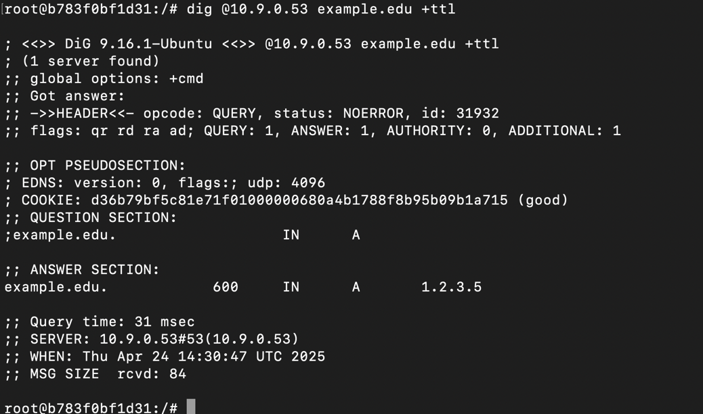

**Task 4: DNSSEC Keytrap Attack Simulation Report**

**Objective:** To simulate the DNSSEC Keytrap attack by increasing the number of DNSSEC keys (ZSKs and one KSK), observe the CPU utilization at the local DNS server, and demonstrate how adding more keys affects performance.

**Step 1: Setup smith2022.edu Name Server**

**1.1 Directory Creation**

* Setting up smith2022.edu folder

**1.2 Key Generation** Used the following commands:

# 1 Wrote a script to generate n number of ZSKs

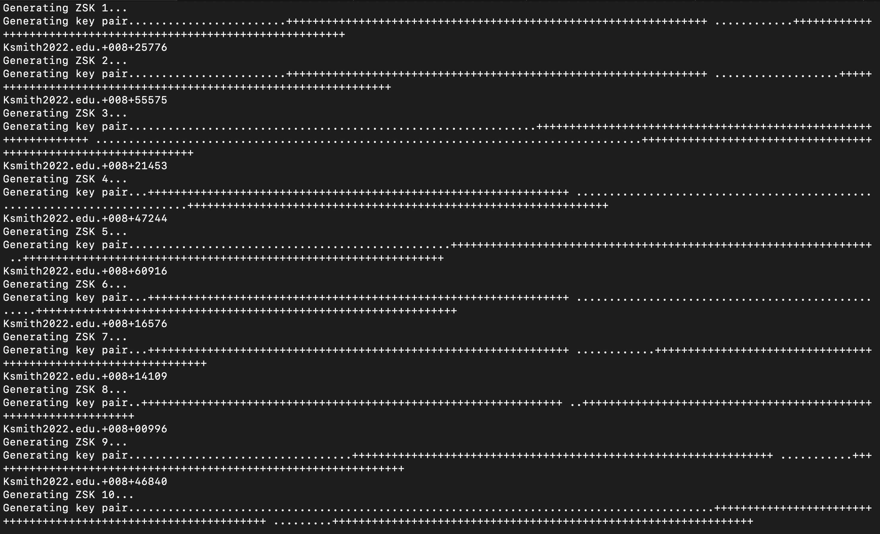

**1.3 Zone Signing** Signed the zone file:

sudo dnssec-signzone -S -e 20501231000000 -o smith2022.edu smith2022.edu.db

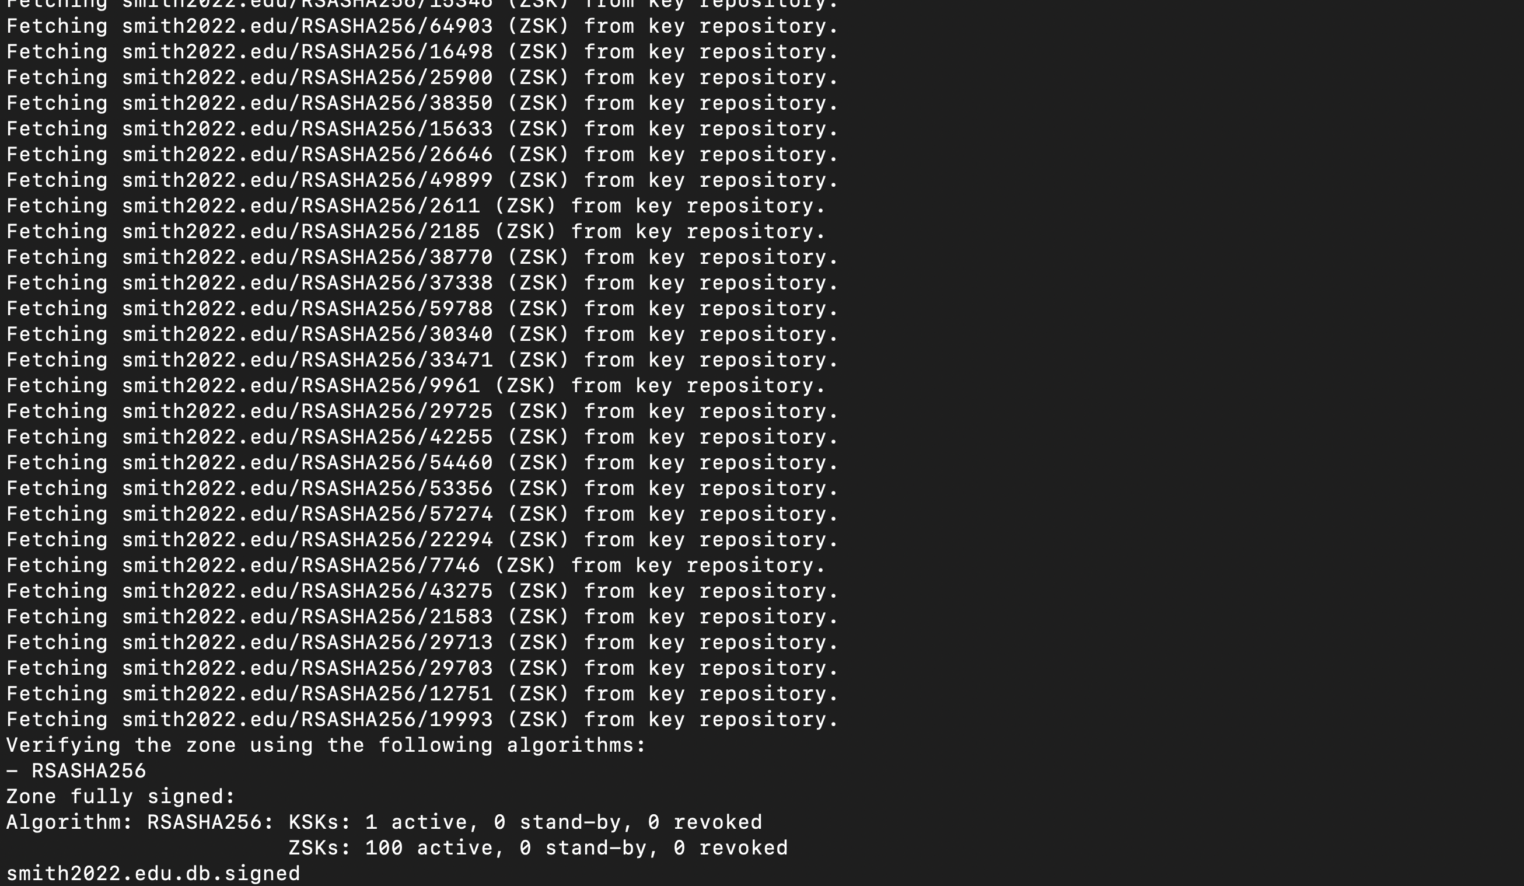

**1.4 Updated BIND Configuration** Updated /etc/bind/named.conf.seedlabs:

zone "smith2022.edu" {

type master;

file "/etc/bind/smith2022.edu.db.signed";

};

**1.5 DS record sharing** Copied the dsset-smith2022.edu. file to the EDU nameserver (edu-10.9.0.60) and included it in edu.db:

$INCLUDE ../etc/bind/smith2022/dsset-smith2022.edu.

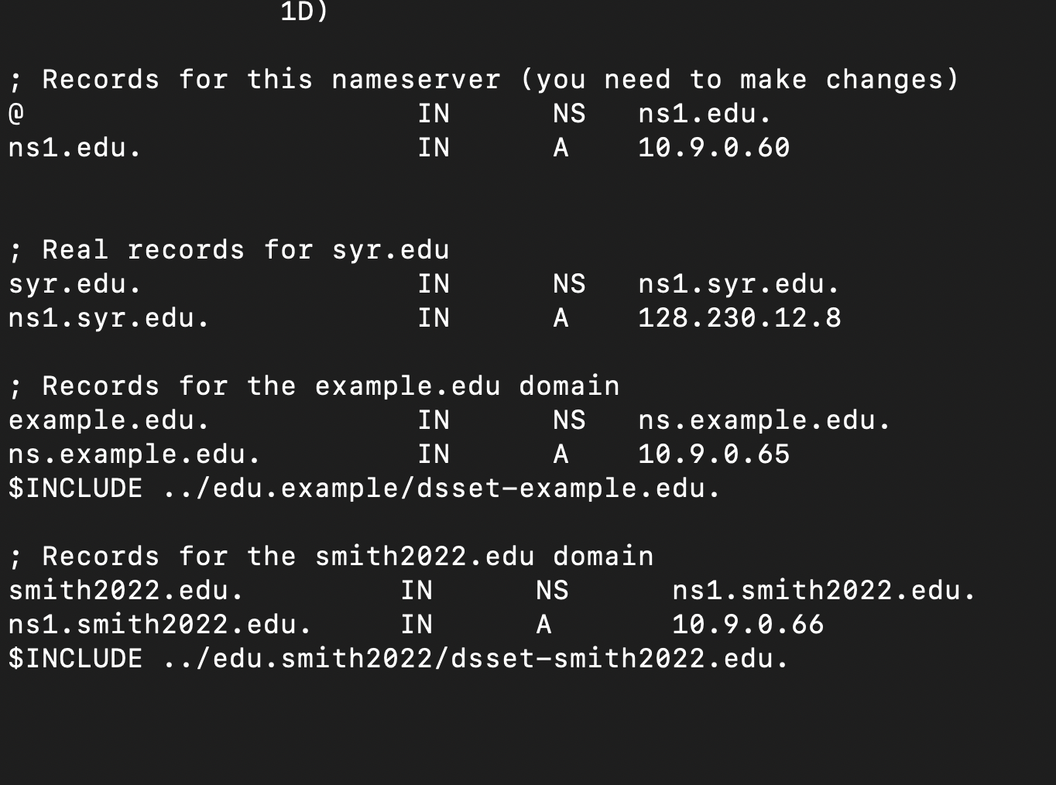

**1.6 Re-signing** Re-signed the edu.db file and restarted named:

dnssec-signzone -S -e 20501231000000 -o edu edu.db

**1.7 Re-signing** Re-signed the root.db file and restarted named:

dnssec-signzone -S -e 20501231000000 -o root root.db

**Step 2: Dig Query and CPU Logging**

**2.1 CPU Monitoring Script**

#!/bin/bash

LOG_FILE="docker_cpu_log.csv"

echo "Timestamp,Container,CPU%" > "$LOG_FILE"

while true; do

TIMESTAMP=$(date +"%Y-%m-%d %H:%M:%S")

docker stats --no-stream --format "{{.Name}},{{.CPUPerc}}" | while read line; do

echo "$TIMESTAMP,$line" >> "$LOG_FILE"

done

sleep 1

done

**2.2 Running Dig Commands**

for i in {1..20}; do

dig @10.9.0.53 www.smith2022.edu +dnssec

done

**Step 3: Running the same above query for smith2022.edu (100 keys, 150 keys)**

**Step 4: Graph of CPU Usage vs Number of Keys**

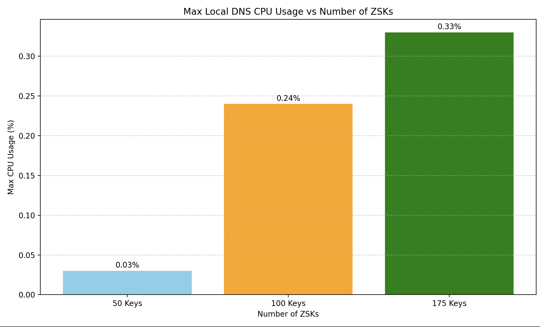

**Observations**

* As the number of ZSKs increases, the max CPU usage on the local DNS server increases.
* DNSSEC verification becomes more computationally expensive with a higher number of signatures in a zone.
* The Keytrap attack leverages this overhead to degrade server performance.

# ANTI-PLAGIARISM STATEMENT  <Include it in your report>

*I certify that this assignment/report is my own work, based on my personal study and/or research and that I have acknowledged all material and sources used in its preparation, whether they be books, articles, reports, lecture notes, and any other kind of document, electronic or personal communication. I also certify that this assignment/report has not previously been submitted for assessment in any other course, except where specific permission has been granted from all course instructors involved, or at any other time in this course, and that I have not copied in part or whole or otherwise plagiarised the work of other students and/or persons. I pledge to uphold the principles of honesty and responsibility at CSE@IITH. In addition, I understand my responsibility to report honour violations by other students if I become aware of it.*

Name: Divyanshu Ranjan

Date: 24/04/2025

Signature: Divyanshu